IS Number 10, 11, 12

10. Use Case Diagram
The diagram below shows the system boundary, the four major actors and the main use cases of the Waste Management System, including the include relationships between recording a collection, capturing the weight reading and calculating the net weight, and between updating collection status and the automated hourly report.
Use Case Diagram – Waste Management System
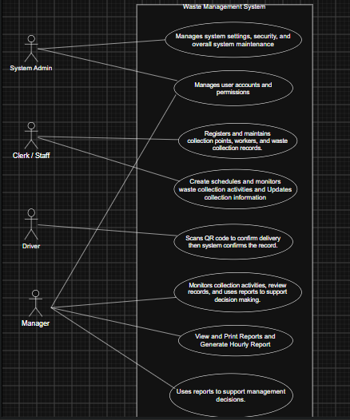

11. Detailed Use Case Specifications

UC01 – Record Waste Collection and Capture Weight
Field |  | Details
Use Case ID |  | UC01
Use Case Name |  | Record Waste Collection and Capture Weight
Primary Actor |  | Waste Management Staff
Other Actors |  | Admin (assigns the collection); System (calculates net weight); Manager (receives resulting report)
Purpose |  | To record the outcome of a waste collection, including an accurate net weight figure, at the point of collection.
Trigger |  | A Waste Management Staff member completes a collection at an assigned collection point and is ready to submit the result.
Preconditions |  | The user is logged in with the Waste Management Staff role; the collection has been scheduled and assigned by Admin.
Postconditions |  | The collection record is saved with a valid gross weight, net weight and status; the record becomes available for reporting.
Related Requirements |  | FR19, FR20, FR21, FR22
Step | Actor Action |  | System Response
1 | Waste Management Staff selects the assigned collection. |  | System displays the collection details and a field for the gross weight reading.
2 | Waste Management Staff enters the gross weight read from the scale. |  | System retrieves the site/tare weight for the collection point.
3 | — |  | System calculates the net weight (gross − tare).
4 | Waste Management Staff submits the collection. |  | System validates the net weight and saves the record with status Completed.
5 | — |  | System includes the record in the next hourly summary report.

Alternative / Exception Flows
Ref. | Condition / Alternative | Required Response
A1 | Calculated net weight is negative (gross weight is less than the site/tare weight) | System rejects the entry, displays an error message, and prompts the Waste Management Staff to re-enter the gross weight.
A2 | Collection has not been assigned to the logged-in Waste Management Staff | System prevents the collection from being selected and displays an appropriate message.

UC02 – Manage Collection Points

Field |  |  | Details
Use Case ID |  |  | UC02
Use Case Name |  |  | Manage Collection Points
Primary Actor |  |  | Office clerk
Other Actors |  |  | Manager
Purpose |  |  | To maintain accurate information about collection points, including the site/tare weight used in net weight calculations.
Trigger |  |  | Office clerk needs to add a new collection point or update existing collection point details.
Preconditions |  |  | The user is logged in with the office clerk role.
Postconditions |  |  | Collection point information, including the site/tare weight, is saved and available for scheduling and weight calculation.
Related Requirements |  |  | FR02,FR03, FR05, FR07, FR09, FR19, FR20 BR01
Step | Actor Action |  |  | System Response
1 | Office clerk selects Add/Edit Collection Point. |  |  | System displays a form for the collection point's name, location and site/tare weight.
2 | Office clerk enters or updates the details. |  |  | System validates that the required fields, including the site/tare weight, are complete and numeric.
3 | Office clerk submits the form. |  |  | System saves the collection point record and updates the list of available collection points.
Ref. |  | Condition / Alternative |  |  | Required Response
A1 |  | Required fields missing or the tare weight is not a valid number |  |  | System displays a validation message and does not save the record until corrected.

UC03 – Manage Waste Collection Driver Records
Field |  |  | Details
Use Case ID |  |  | UC03
Use Case Name |  |  | Manage Waste Collection driver Records
Primary Actor |  |  | Office Clerk
Other Actors |  |  | —
Purpose |  |  | To register and maintain accurate driver records that can be assigned to collections.
Trigger |  |  | Office clerk needs to register a new driver or update an existing driver's details.
Preconditions |  |  | The user is logged in with the office clerk role.
Postconditions |  |  | A driver record with a unique driver ID is saved and available for assignment.
Related Requirements |  |  | FR04, FR06, FR07, FR26, FR27, FR28
Step | Actor Action |  |  | System Response
1 | Office clerk selects Add New driver. |  |  | System displays a worker details form.
2 | Office clerk enters the driver’s name, ID and contact details. |  |  | System validates the details entered.
3 | Office clerk submits the form. |  |  | System saves the worker record and assigns a unique driver ID.
Ref. |  | Condition / Alternative |  |  | Required Response
A1 |  | driver details are incomplete or invalid |  |  | System displays a validation message and requires the office clerk to correct the details before saving.

UC04 – Assign Worker to Collection

Field |  |  | Details
Use Case ID |  |  | UC04
Use Case Name |  |  | Assign Worker to Collection
Primary Actor |  |  | Office clerk
Other Actors |  |  | Waste Management Staff (receives the assignment)
Purpose |  |  | To allocate a registered driver to a scheduled collection at a specific collection point.
Trigger |  |  | Office clerk creates or updates a collection schedule.
Preconditions |  |  | The driver and collection point already exist in the system.
Postconditions |  |  | The collection is assigned to a specific driver and appears in that driver 's assigned collections.
Related Requirements |  |  | FR06, FR07, FR17,
Step | Actor Action |  |  | System Response
1 | Office clerk selects a collection point and date. |  |  | System displays available registered drivers.
2 | Office clerk selects a driver to assign. |  |  | System links the driver to the scheduled collection.
3 | Office clerk confirms the assignment. |  |  | System saves the schedule with status Outstanding.
Ref. |  | Condition / Alternative |  |  | Required Response
A1 |  | Selected driver is already assigned to a conflicting collection at the same time |  |  | System displays a warning and requires the Admin to select a different driver or time.

UC05 – Generate Hourly Collection Report (Automated Multi-User Workflow)
Field |  |  | Details
Use Case ID |  |  | UC05
Use Case Name |  |  | Generate Hourly Collection Report
Primary Actor |  |  | Waste Management Manager
Other Actors |  |  | Waste Management Staff clerk (creates schedule)
Purpose |  |  | To automatically compile and deliver an up-to-date summary of waste collection activity to management every hour, without requiring a manual request.
Trigger |  |  | 60 minutes have elapsed since the previous hourly report was generated.
Preconditions |  |  | The system is running; one or more collections have been recorded during the period.
Post-conditions |  |  | An hourly report reflecting all collections recorded in the period is available to the Manager.
Related Requirements |  |  | FR08, FR09, FR10, FR11, FR12, FR13, FR14, FR17, FR22, FR23, FR24
Step | Actor Action |  |  | System Response
1 | Staff clerk creates the collection schedule and assigns workers. |  |  | System stores the scheduled collections.
2 | Waste Management Staff clerk records collections and weight readings throughout the hour. |  |  | System validates, calculates net weight and saves each record.
3 | — (scheduled) |  |  | Every 60 minutes, the system automatically compiles a summary of all collections recorded since the previous report.
4 | — |  |  | System makes the hourly report available to the Waste Management Manager.
5 | Manager opens/reviews the report. |  |  | System displays the report on-screen and allows it to be printed.
Ref. |  | Condition / Alternative |  |  | Required Response
A1 |  | No collections were recorded during the hour |  |  | System still generates the report, indicating that no activity occurred in that period.

UC06 – View and Print Collection Reports

Field |  |  | Details
Use Case ID |  |  | UC06
Use Case Name |  |  | View and Print Collection Reports
Primary Actor |  |  | Waste Management Manager
Other Actors |  |  | Staff clerk
Purpose |  |  | To allow management to review and print collection activity for a selected period, worker or collection point on demand.
Trigger |  |  | Manager needs to review collection performance outside of the automatic hourly report.
Preconditions |  |  | The user is logged in with the Manager role; collection records exist in the system.
Postconditions |  |  | The requested report is displayed and, if required, printed.
Related Requirements |  |  | FR04, FR10, FR11, FR12, FR14, FR17, FR23, FR24
Step | Actor Action |  |  | System Response
1 | Manager selects Reports from the dashboard. |  |  | System displays report filter options (date range, collection point, worker).
2 | Manager selects filters and requests the report. |  |  | System retrieves and displays matching collection and weight records.
3 | Manager selects Print. |  |  | System sends the report to the selected printer.
Ref. |  | Condition / Alternative |  |  | Required Response
A1 |  | No records match the selected filters |  |  | System displays a message indicating that no matching records were found.

12. Activity Diagrams
Three Activity Diagrams have been prepared for the project's important business processes. Figure 2 models the compulsory multi-user workflow, showing how Admin, Waste Management Staff, the System and the Manager interact across the collection-and-reporting process using swimlanes.
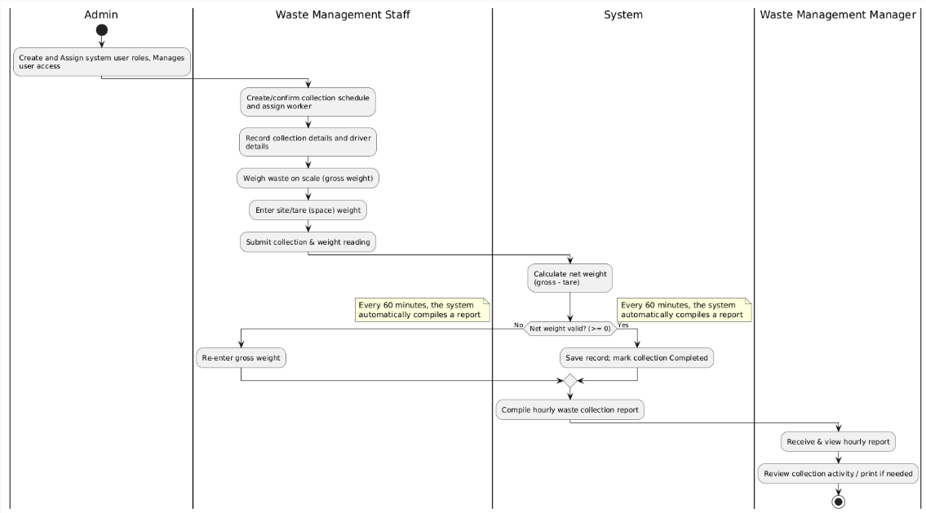
Activity Diagram – Record Waste Collection and Automated Hourly Reporting (multi-user workflow)

models the process of registering a new waste collection worker.
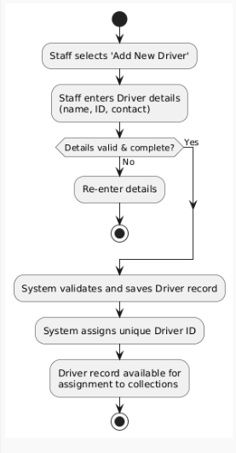

Activity Diagram – Register Waste Collection Worker

models the process of adding or updating a collection point, including its site/tare weight.
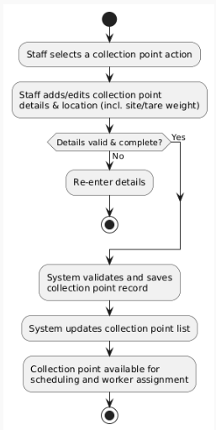
Activity Diagram – Manage Collection Point

